Project Description Document  
Software Construction

short line E-Legal

Group Members:

**Faizan Zafar 00000111528**

**Muhammad Murtaza Shiraz 00000111422**

**Shoaib Sarwar 00000111416**

# Table of Contents

# Table of Contents........................................................................................................................ii

# 1. Introduction........................................................................................................................... 4

# 2. Problem Statement.............................................................................................................4

# 4. Solution................................................................................................................................. 4

# 5. Solution's Novelty............................................................................................................... 5

# 6. Timeline of Completion..................................................................................................... 5

# 

# 

# 

# 

# 

# 1. Abstract:

This report overviews our semester project on law advisory system named as “E-Legal”. The report elaborates different activities of software construction life cycle i.e Requirements gathering, design, implementation and testing. The main focus is our implementation and different approaches that we we use to design and implement the required system.

# 2. Introduction:

The system of law and order in Pakistan faces a lot of problems. The legal system fails to produce efficient law practices and justice for clients due to rigid government policies and elements like corruption, fraud etc.

There is a high inclination among the youth to join a legal profession due to any number of reasons. However, they are unaware of the problems newly law graduates face in the real world.

Usually, they will have to join an established firm or work with a senior advocate to gain some necessary experience for the profession. The inflexible attitudes of these professionals and the huge time it takes to gain a standing in the industry hinders the progress rate of these individuals and eventually the law and order sector.

Lawyers with fake degrees and little to no knowledge of the legal system are working without any check and balance by the authorities.

Lawyers charge a high amount of fee per session and are not available readily for the clients.

Women in the law and order sector are oppressed. They are subject to several obstacles and have little say in their duties and responsibilities.

Clients have little to no knowledge of the category of lawyer they require for their tasks.

Overall, the legal system has affected the life of the common man as well as important departments within the government and in some direct or indirect way.

# 

# 3. Literature Review:

Most of the modules of the project is according to already made project, called Law Advisor. It is web platform and most of the functionalities of our project is according to Law Advisor. Law advisor combines both the clients and the lawyers at one platform. It provides different services to lawyers and client based upon the need of each category, For example to the client, the application offers services such as ask questions, view answers from the lawyers, contact lawyers to add their respective cases. Similarly for the lawyers it provides the services like case management in which they can view, add , delete and edit their cases according to the user needs. Moreover lawyer can post different articles on their profiles where clients can see them easily. Lawyers can also view the questions asked by the clients and answer them. On the other hand clients can also view the answers of the lawyers on their questions and on the questions posted by other users.

# 4. Project Problem Statement:

The current system of law and order in Pakistan encounters various problems especially in areas of law professionals and people who seek their services. Low incentives, corruption, fraudulent regulation of finances, naïve clients and availability of lawyers are some aspects. There is no uniform platform in Pakistan for gaining legal advice and distinguishing between all aspects of it. Clients have a nonspecific approach to every type of legal problem and this trend needs to be minimized. Our aim is to tackle these problems through a generic approach in our system.

# 

# 

# 5. Design

In order to cater to all the above mentioned problems, we have designed and developed a web application that will gather all interested lawyers and clients on one platform. The web application will be a major advancement to the current system of lawyer's’ practice management in Pakistan. Moreover, clients will be able to find the lawyers that suit to their requirements and availability. The application has two main design interactions:

* Interface for the clients, which provides an array of functionalities to choose from.
* Interface for the lawyers, which will help the lawyers to render their services in the legal industry.

We have included one functionality per web page so as to achieve separation of concerns. The design of the web application is simple to understand for a first time user and developer. Following screenshots show our efforts in this area:

# 6. Implementation

We had different options for the implementation tools and technologies for this project and we opted for web application and related tools. In this way, we had a whole variety of languages and platforms to choose from.

The following web based tools & technologies have been used for the development of this project:

Front End:

* HTML
* CSS which extends to Bootstrap
* JavaScript which extends to jQuery

Back End:

* PHP
* JavaScript
* MySQL
* WAMP Server

Our project fully contains its stated features with these technologies and use of additional frameworks is not included. We have used agile development approach whereby increments and iterations shall be executed on the original codebase to produce the final product.

# 7. Results

The project successfully performs its intended operations and the flow of data can be tracked fully within the application. We have achieved successful results in terms of management of cases and appointments, storage and retrieval of user data, messaging between lawyers and clients, posting of articles and tips for law students and clients.

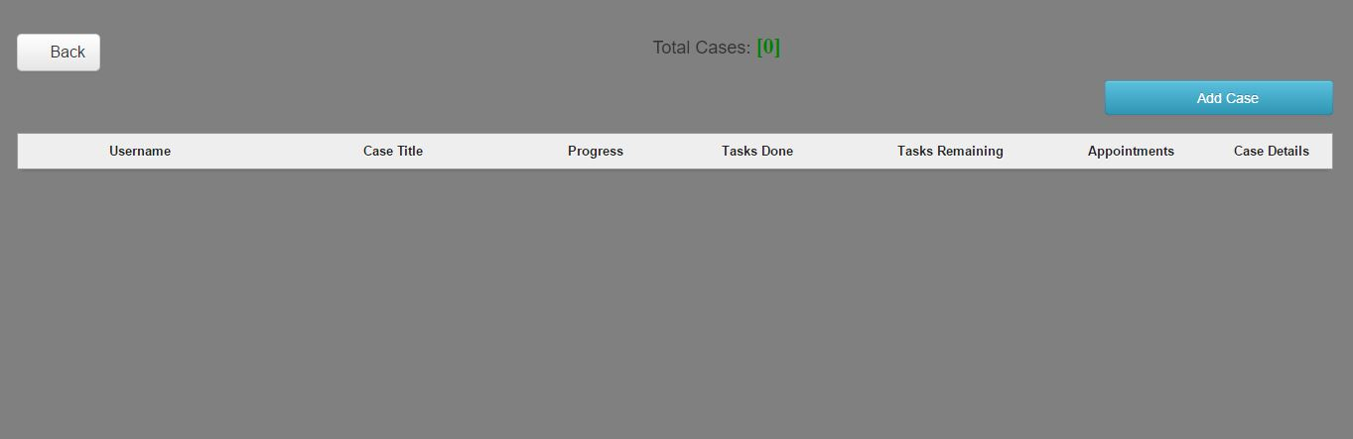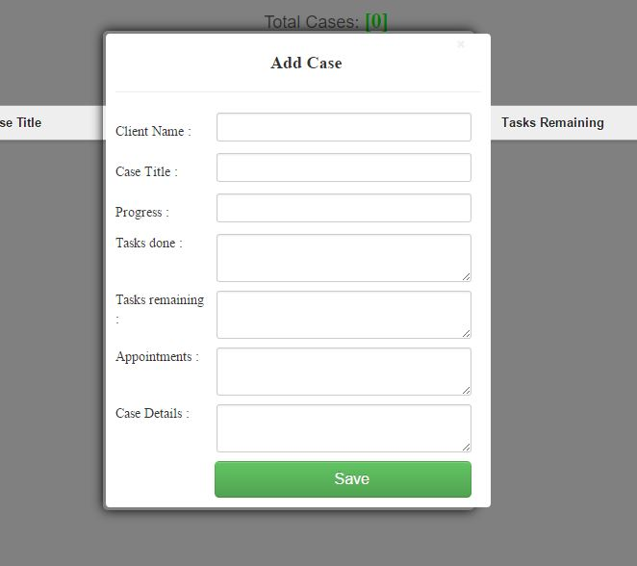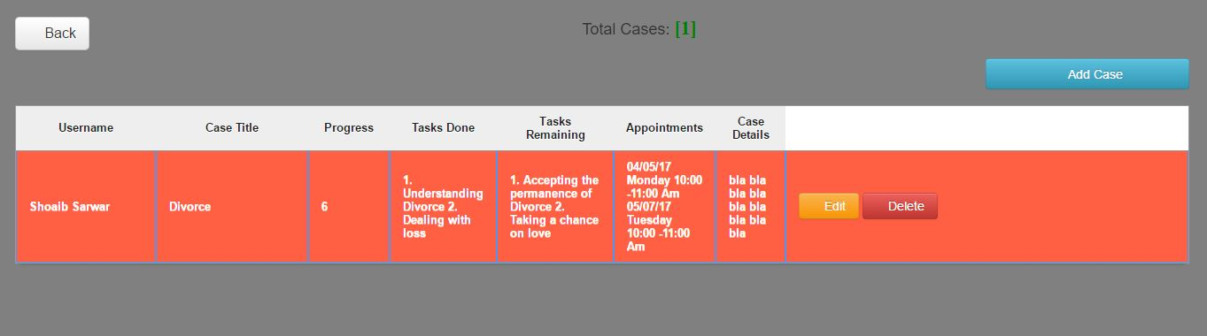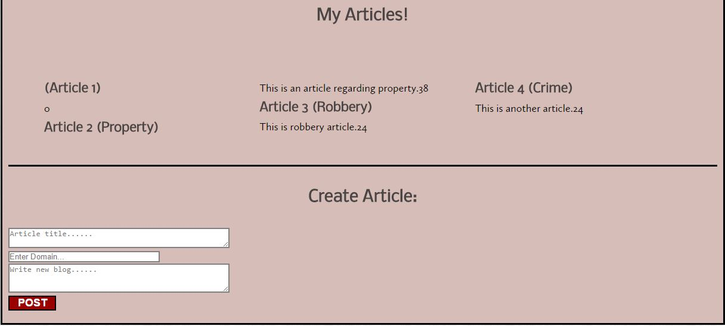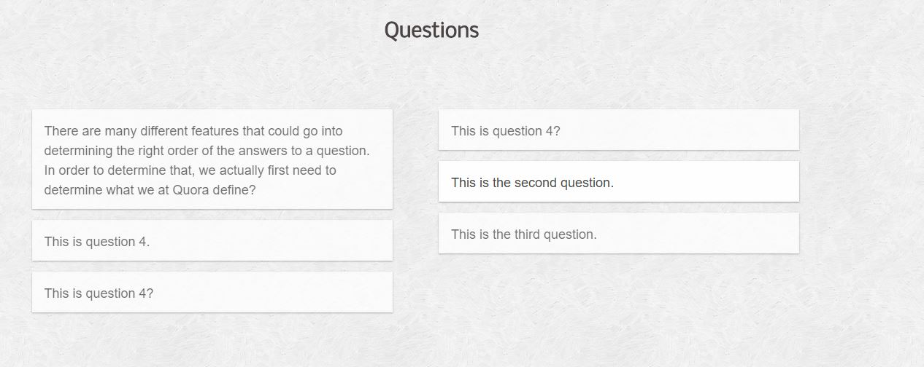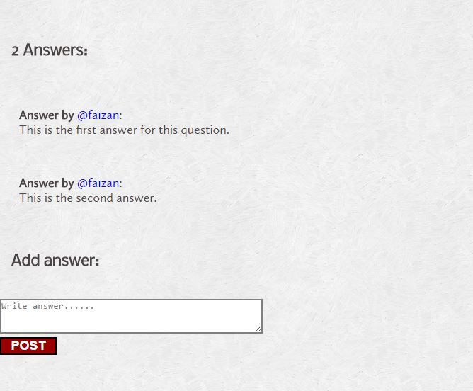

# 8. Conclusion

E-Legal is a state-of-the-art enterprise level application that meets the requirements of its intended audience. Its use at a large scale will smoothen the workflow for lawyers and prospective clients. Its welcoming user experience is an added feature. Development of the application was a good learning experience for all members.

**Github Link:**

[**https://github.com/faizanzafar95/SE312-Semester-Project**](https://github.com/faizanzafar95/SE312-Semester-Project)

**Note:**

**4 late days were used in the making of this semester project**

short dash